Multiplayer

Basic Game Rules
- Capture the Flag gameplay, with variable locations on the flag but one delivery location per player per gameplay session.
  - The “flag” spawns like the passengers in Road Rage
  - Both players have only one destination for a gameplay session (e.g., if you are delivering to the Kwik-E-Mart, then that’s where you’ll always take the flag)
  - You steal the flag by ramming the other player
  - First one to N flags wins
  - Delivery/pickup/steal mechanism the same as last year:
    - One touch pickup/steal/delivery
    - No tag-backs (i.e., stealing is disabled for a few seconds after the flag is stolen))
  - No on-foot capability. Players will not be able to get out of the car
- Counter measures:
  - Heavy Flag –the flag bearer is slower than the attacker
  - “Bullet Time” slow-motion f/x and speed burst move used to steal the flag (see Bullet Time section below)
- Vehicle Damage: Unlike single-player, your vehicle may not come to a complete stop when damaged out. Instead it will slow done (to a designer-tuneable speed) and the reset (tuneable time delay).

Vehicles
All the drivers from single player will be used in Head to Head:
- Bart Ferrini  - Apu Trans Am  - Snake Bandit  - Homer Barracuda  - Frink Hover Car  - Comic Book Guy Gremlin | - Marge Canyonero  - Grampa WWII jeep  - Homer Pink Sedan  - Cletus Pickup truck  - Wiggum Police car  - Lisa VW Bug

We may have to tune vehicles tuned separately for the multiplayer mode. – TBD

Dialog – Taunt Button

There are a number of multiplayer-specific dialog events (see Dialog document for full details).

The Taunt button (replaces the horn) has additional functionality in that it responds to the game context. It plays a line of dialog specific to the game session situation:
- Losing by < 3 points
- Losing by > 2 points
- Winning by < 3 points
- Winning by > 2 points
- Game is tied
- Carrying winning flag
- Opponent is carrying winning flag

Presentation
  - HUD: The HUD will be very similar to single player.
- Need a better way of showing who has the flag – vehicle glow or f/x, as is used in first person shooters
  - Front-End – there will be two front end screens before entering the game:
- Setup:
  - One of four destination bases (all within Downtown level)
  - Bullet Time options: Normal, Slow Recharge, Off
  - Point to Win (5, 10, 15)
- Choose your character/vehicle
- Scoring: TBD
- Start/end of game: TBD

Bullet Time
“Bullet Time” will be used to create and emphasize player battlers in H2H. It is a slow-motion effect combined with a speed-burst, so that the attacking player has a tool to help steal the flag.

Gameplay

The sequence of events goes something like this:

- Each player has a meter on their HUD that fills up over time
  - The meter gets an extra boost when you hit a breakable or movable physics object.
- When the meter is full the attacking player can initiate bullet time
  - Only the chaser can initiate it. So you can’t use it when you have the flag.
- The game slows down to slow motion (exact percentage of full speed to be tuned).
  - The transition in sim-rate is gradual from the game’s normal speed to slow-motion
  - The transition is accompanied by a stylized sound effect
- During slow-motion a HUD “fighter-jet style” target object will animate, letting the user know that a countdown is on. The length of this countdown is tuneable, but is expected to be between 3-7 seconds. E.g.:
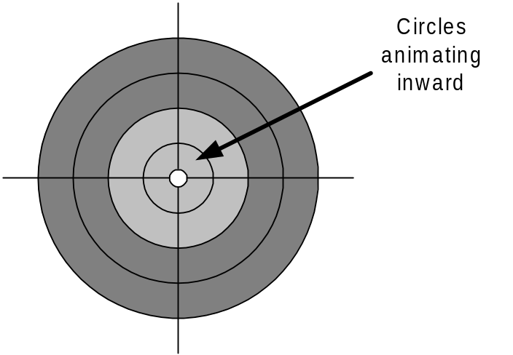
- Once the countdown is complete, the attacking player gets a speed burst (amount TBD) that will accelerate their vehicle, giving them a shot at the flag-carrier
- A couple seconds after the speed burst, bullet time reverts back to normal time (gradually and with a sound f/x)

Presentation

- Gradual transition in sim-rate from full speed to slow speed (and vice versa)
  - Sound effect accompanies transition in each direction (to and from full speed)
  - Music fades out during transition
- HUD power-meter pulses when full and the other player has the flag
- “Targeting” animated HUD object as a countdown timer, accompanied by an “electro-mechanical power build up” kind of sound f/x
- Speed-burst sound f/x

Screen Merge

This feature is to be investigated, and prototyped if is not overly complicated to do so:

- When bullet-time is initiated, the attacking player’s screen expands to full –screen (presentation/transition to be technically driven – in other words, whatever is most practical)
- This only takes place if the two players are “close enough” to both be seen on one screen
  - This “close enough” calculation has to take into account the relative velocity of both players (i.e., it might be a chase from behind, or a head-on encounter)
- A special “target camera” looks at both cars. There are a couple possibilities here:
  - A) The position of the camera doesn’t change (i.e., relative to the attacker’s car) but the target becomes the defending car
  - B) The camera picks a middle position between both cars and tries to show them both
- When bullet time ends (or if players get too far apart) the screens split again
- If this feature works well, we may also want to try disabling the ability to initiate bullet time when the cars are “too far apart”. This is definitely something to test out – it could be frustrating.

Multiplayer Tuneable Variables

Tuneable variables for multiplayer mode are:
- Time-delay on tag backs (i.e., flag-stealing is disabled for this amount of time)
- Factor of flag heaviness (% of other player’s top speed?)
- Damaging out:
  - Factor of speed penalty (% of top speed)
  - Amount of time penalty for damaging out
- Bullet Time:
  - The transition time from normal speed to slow-motion (e.g., 0.5 seconds)
  - The degree to which the game slows down (e.g., 25% of normal time)
  - The duration of the countdown to speed-burst during slow-motion (3-5 seconds?)
  - The amount of the speed burst (in KM/H?)
  - The duration that slow-motion lasts after speed-burst has been fired
  - The speed at which the bullet-time meter regenerates
  - The amount of bonus added to the bullet-time meter for hitting a breakable
  - Bullet Time screen merge:
    - Degree of separation for initiating screen-merge effect (accounting for both chase and head-on situations)

